IH2 400
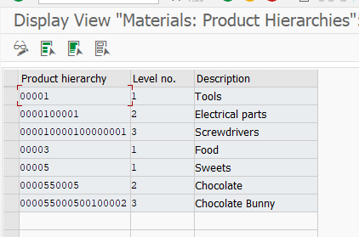

IH2 100

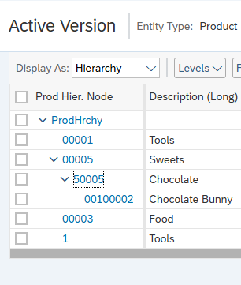

Replication does not change anything …

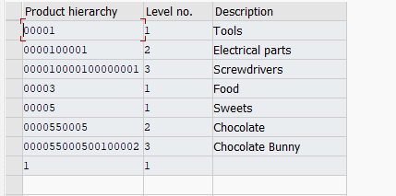

Delete all (step by step), last levels, save, last levels, save, …


